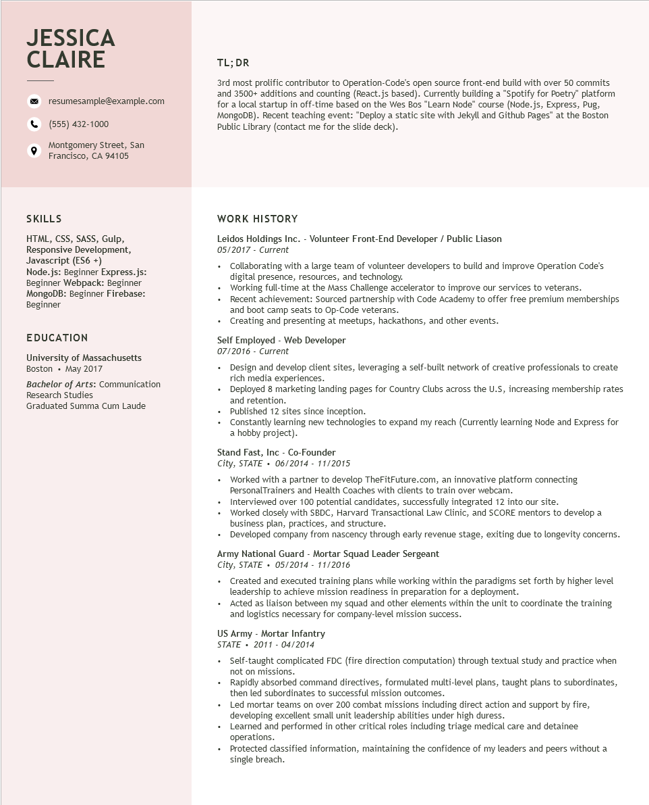
JESSICA CLAIRE
resumesample@example.com
(555) 432-1000
Montgomery Street, San Francisco, CA 94105
TL;DR
3rd most prolific contributor to Operation-Code's open source front-end build with over 50 commits and 3500+ additions and counting (React.js based). Currently building a "Spotify for Poetry" platform for a local startup in off-time based on the Wes Bos "Learn Node" course (Node.js, Express, Pug, MongoDB). Recent teaching event: "Deploy a static site with Jekyll and Github Pages" at the Boston Public Library (contact me for the slide deck).
SKILLS
HTML, CSS, SASS, Gulp, Responsive Development, Javascript (ES6+)
Node.js: Beginner Express.js:
Beginner Webpack: Beginner MongoDB: Beginner Firebase: Beginner
EDUCATION
University of Massachusetts Boston⚫ May 2017
Bachelor of Arts: Communication Research Studies
Graduated Summa Cum Laude
WORK HISTORY
Leidos Holdings Inc. - Volunteer Front-End Developer / Public Liason 05/2017 - Current
• Collaborating with a large team of volunteer developers to build and improve Operation Code's digital presence, resources, and technology.
• Working full-time at the Mass Challenge accelerator to improve our services to veterans.
•
Recent achievement: Sourced partnership with Code Academy to offer free premium memberships and boot camp seats to Op-Code veterans.
• Creating and presenting at meetups, hackathons, and other events.
Self Employed - Web Developer
07/2016 - Current
• Design and develop client sites, leveraging a self-built network of creative professionals to create rich media experiences.
• Deployed 8 marketing landing pages for Country Clubs across the U.S, increasing membership rates and retention.
• Published 12 sites since inception.
• Constantly learning new technologies to expand my reach (Currently learning Node and Express for a hobby project).
Stand Fast, Inc - Co-Founder
City, STATE. 06/2014 - 11/2015
• Worked with a partner to develop TheFitFuture.com, an innovative platform connecting PersonalTrainers and Health Coaches with clients to train over webcam.
• Interviewed over 100 potential candidates, successfully integrated 12 into our site.
• Worked closely with SBDC, Harvard Transactional Law Clinic, and SCORE mentors to develop a business plan, practices, and structure.
• Developed company from nascency through early revenue stage, exiting due to longevity concerns.
Army National Guard - Mortar Squad Leader Sergeant
City, STATE⚫ 05/2014 - 11/2016
• Created and executed training plans while working within the paradigms set forth by higher level leadership to achieve mission readiness in preparation for a deployment.
• Acted as liaison between my squad and other elements within the unit to coordinate the training and logistics necessary for company-level mission success.
US Army - Mortar Infantry
STATE
2011-04/2014
• Self-taught complicated FDC (fire direction computation) through textual study and practice when not on missions.
• Rapidly absorbed command directives, formulated multi-level plans, taught plans to subordinates, then led subordinates to successful mission outcomes.
• Led mortar teams on over 200 combat missions including direct action and support by fire, developing excellent small unit leadership abilities under high duress.
⚫ Learned and performed in other critical roles including triage medical care and detainee operations.
Protected classified information, maintaining the confidence of my leaders and peers without a single breach.

